Acceptance Testing
UAT Execution & Report Submission

Date | 13 February 2026
Team ID | LTVIP2026TMIDS79819
Project Name | Electric Motor Temperature Prediction using Machine Learning
Maximum Marks | 4 Marks

Run the application
Open the anaconda prompt go to the project folder and in that go to the flask folder and run the python file by using the command “python app.py”
Copy the HTTP link and paste it into a browser tab.
The following page will be opened

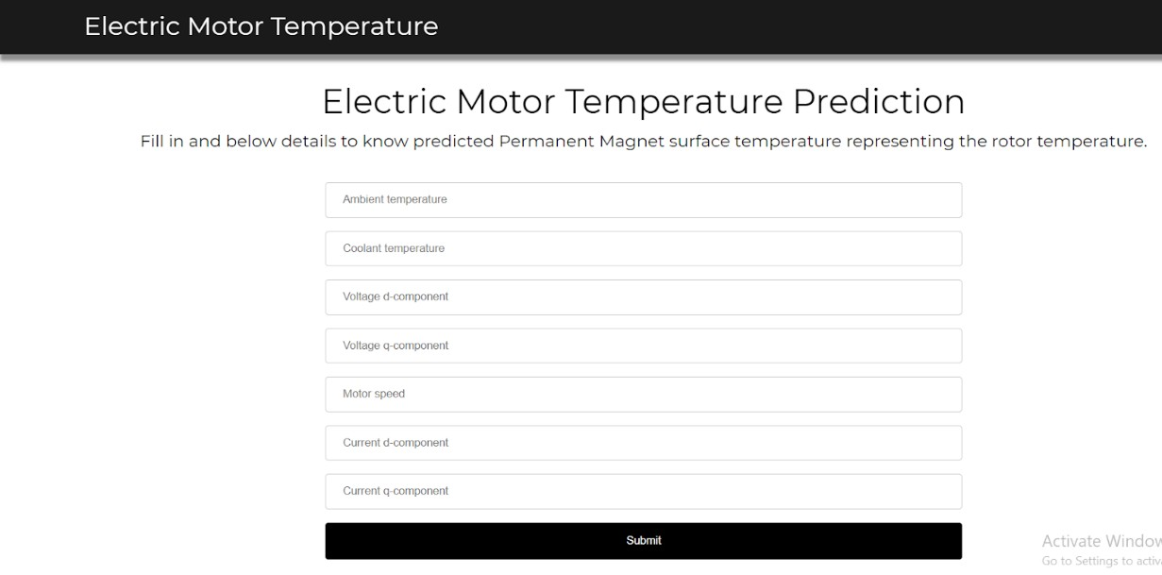
Enter the values and click on predict button, it will predict the temperature of an electric motor
